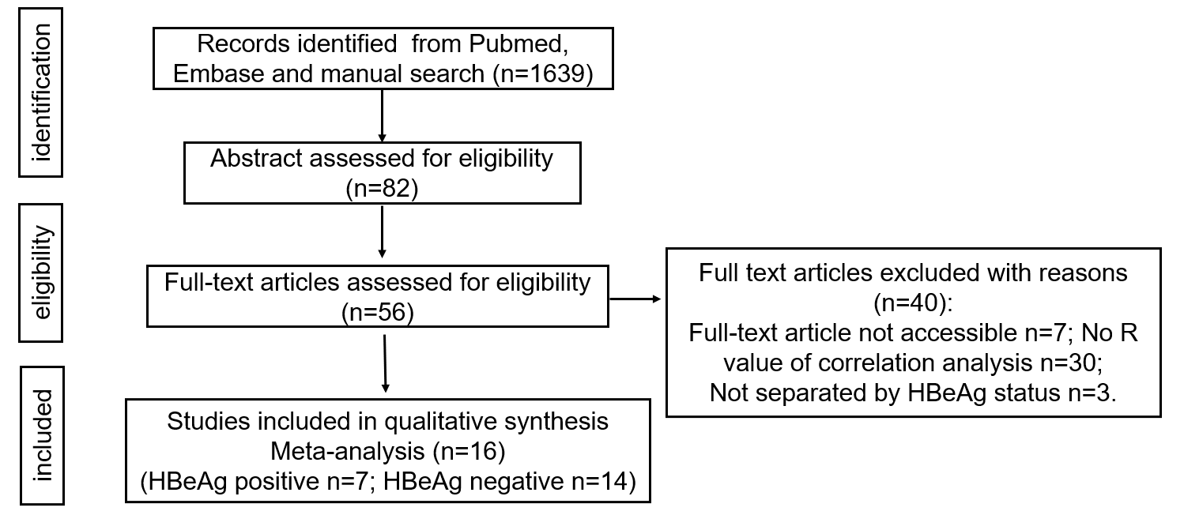
Figure S1. Flow diagram of Study selection.
Search terms were descripted as follow: (1)(relation) OR (relationship) OR (correlation) OR (relevance) OR (relevant) OR (correlate) OR (related); (2)(Alanine Transaminase) or (Transaminase, Alanine) or (Glutamic-Alanine Transaminase) or (Glutamic Alanine Transaminase) or (Transaminase, Glutamic-Alanine) or (Alanine-2-Oxoglutarate Aminotransferase) or (Alanine 2 Oxoglutarate Aminotransferase) or (Aminotransferase, Alanine-2-Oxoglutarate) or (Alanine Aminotransferase) or (Aminotransferase, Alanine) or (Glutamic-Pyruvic Transaminase) or (Glutamic Pyruvic Transaminase) or (Transaminase, Glutamic-Pyruvic) or (SGPT) or (ALT); (3)HBV DNA; (4)HBeAg.

