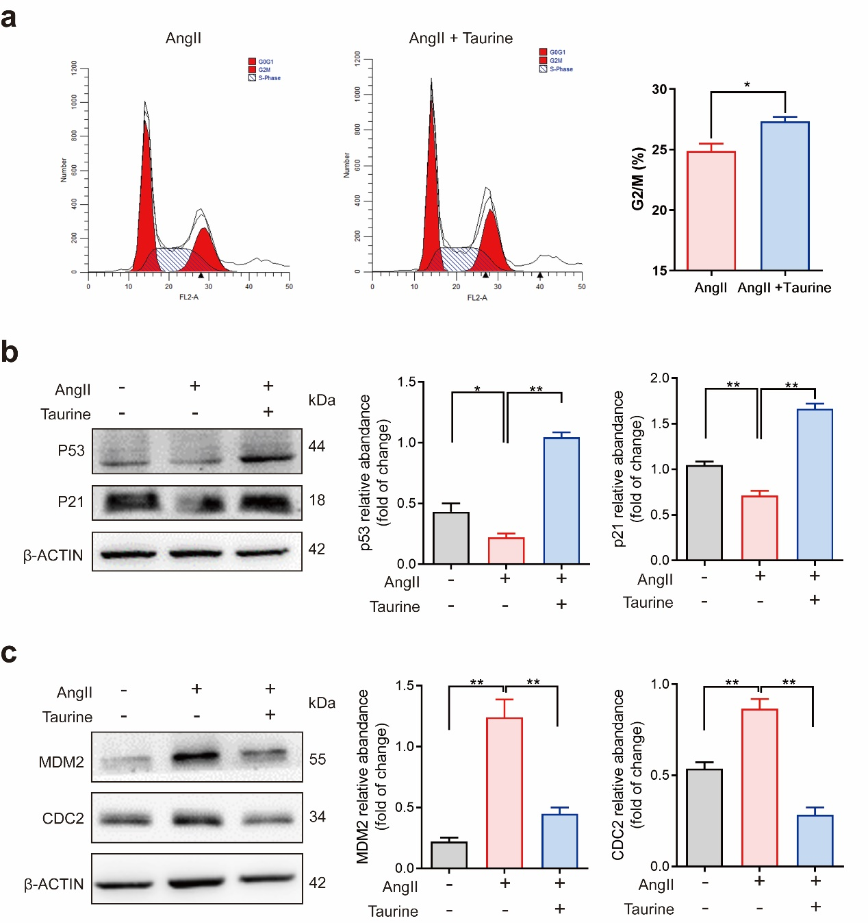

**Supplemental Figure.** **Effects of taurine on the mitosis of smooth muscle cells** (n = 3). (a) The content of G2/M phase cells as shown by flow cytometry after taurine treatment; (b, c) The levels of proteins on the p53-p21 pathway in smooth muscle cells. *: *p* < 0.05; **: *p* < 0.01.