**Supplementary Fig. 1** Distribution of AFP, AFP-L3, and PIVKA-II concentrations by (A) healthy and CLD controls, CLD controls, and HCC; (B) BCLC stage; and (C) etiology.

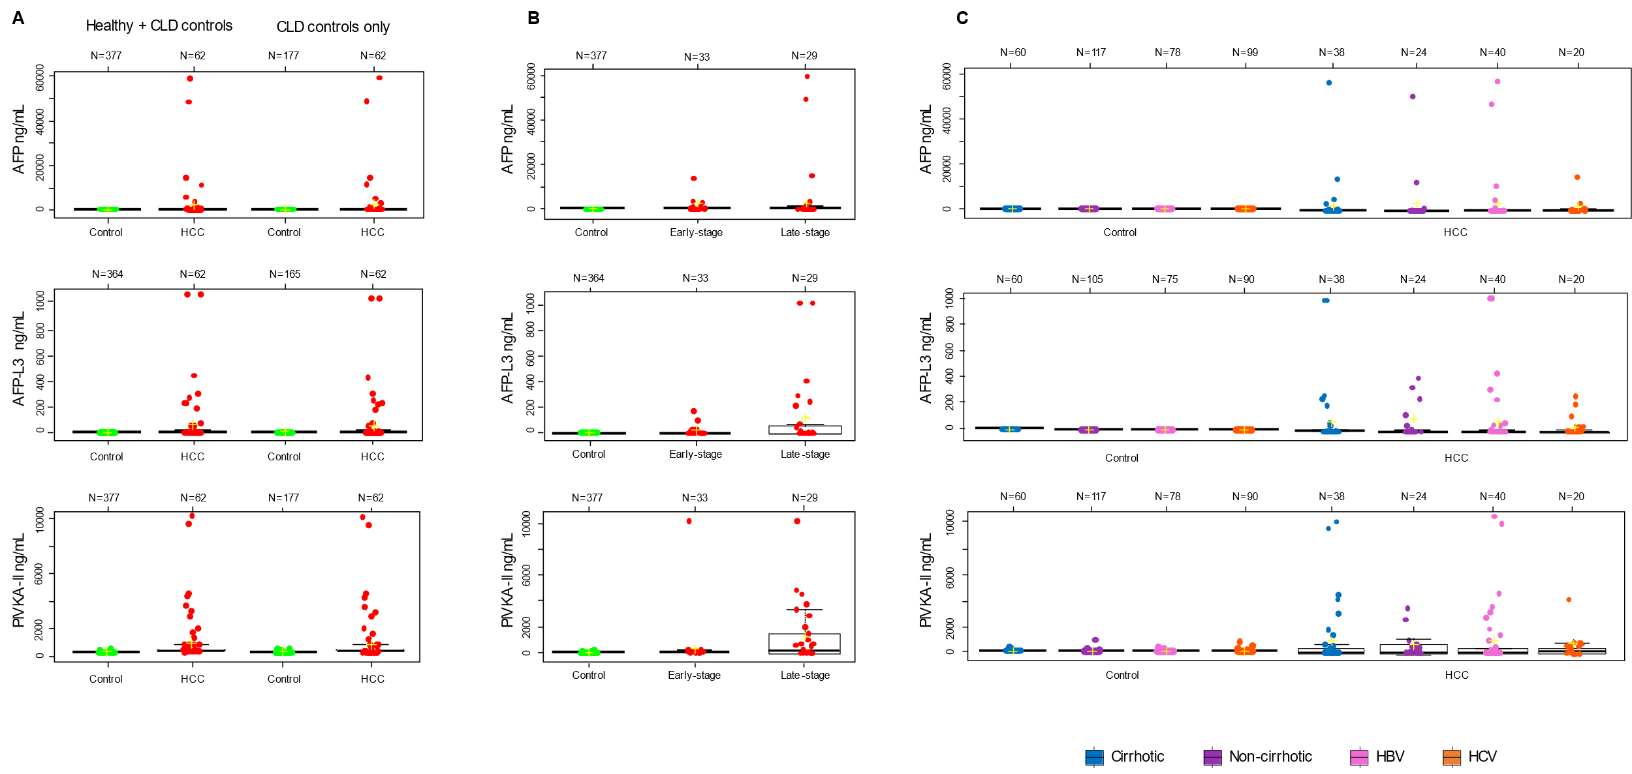

AFP, α-fetoprotein; AFP-L3, *Lens culinaris* agglutinin-reactive fraction of α-fetoprotein; CLD, chronic liver disease; HBV, hepatitis B virus; HCC, hepatocellular carcinoma; HCV, hepatitis C virus; PIVKA-II, protein induced by vitamin K absence or antagonist II**.**