Supplementary Table 2. Generalized anxiety disorder-7
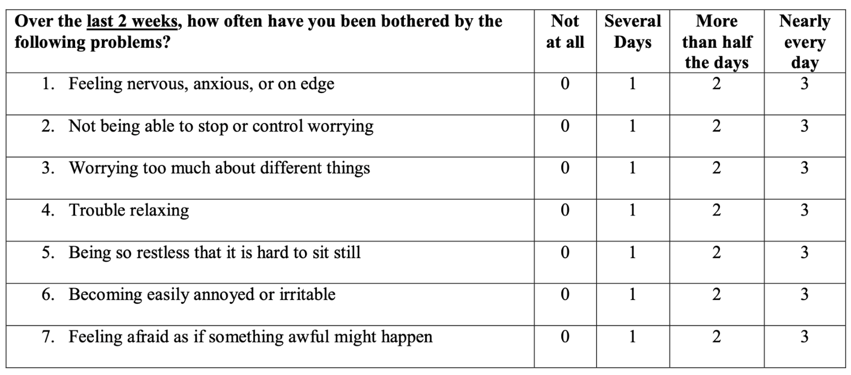
Score 0–4: minimal anxiety; Score 5–9: mild anxiety; Score 10–14: moderate anxiety; Score greater than 15: severe anxiety.

