Supplementary Table 1. Patient health questionnaire-9
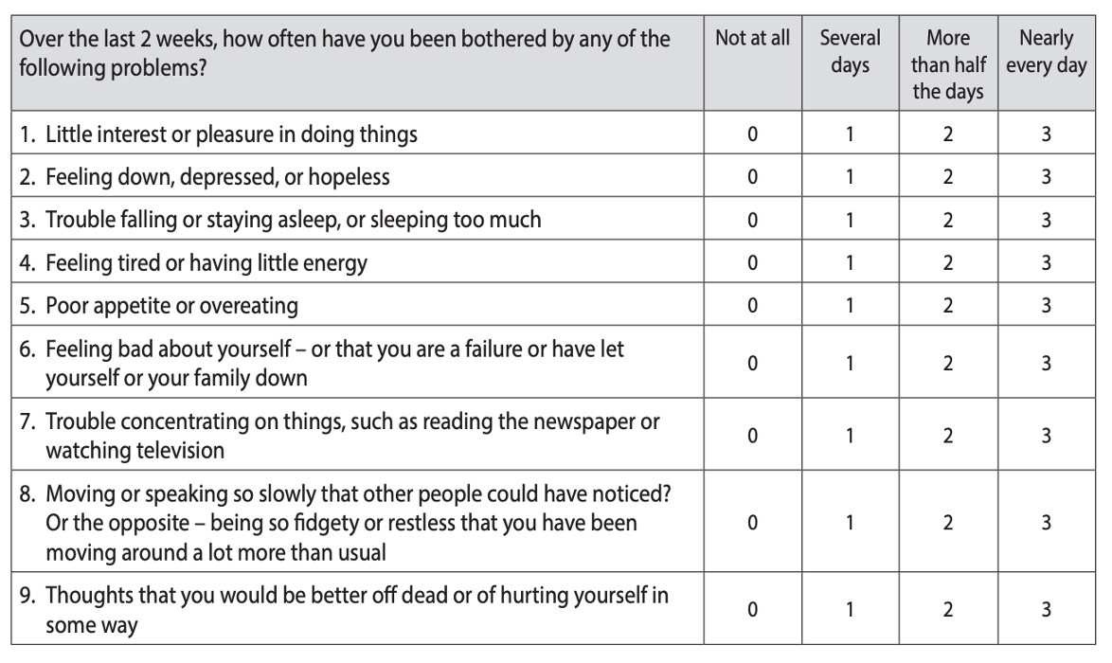
Score 0–4: normal or minimal depression; Score 5–9: mild depression; Score 10–14: moderate depression; Score 15–19: moderately severe depression; Score 20 or more: severe depression.

