Supplementary materials
1.- Sample selection flowchart
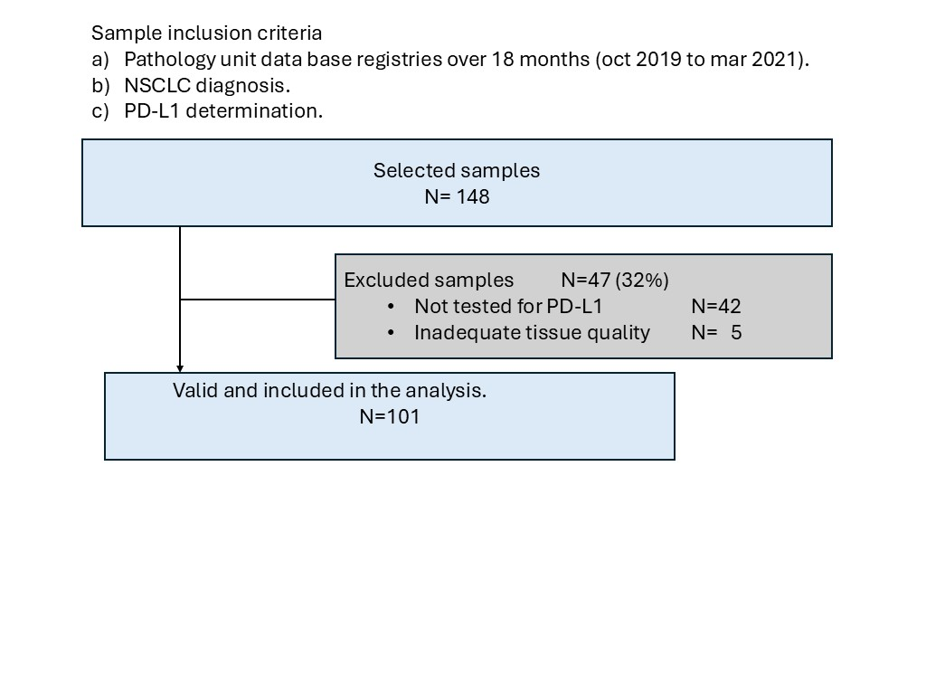
NSCLC, non small cell lung cancer; PD-L1, programmed death ligand 1.
2.-Sample processing details
Samples included endobronchial biopsies (identified in the manuscript as core-needle biopsies, typically 0.4 × 0.4 × 0.1 cm) and surgical specimens (identified in the manuscript as macro biopsies, typically processed as 1 × 1 × 5 cm samples). The full preanalytical period occurred at room temperature. Both types of samples were fixed in neutral buffered formalin, pH 7.2–7.4 (Diapath F0048), with a formalin/sample volume proportion of 10:1. No other fixatives or decalcification processes were used. The dehydration and paraffin-embedding process was automated using Leica ASP3000S equipment. Slides were immediately immunostained for PD-L1 according to manufacturer specifications.

