Supplementary Fig. 1. Area under the curve (AUC) receiver operating characteristics (ROC) for the prediction of significant fibrosis (≥ F2/≥ 8.2 kPa) and advanced fibrosis (≥ F3/≥ 9.7 kPa) using (A) ALT; (B) BMI and (C) HbA1c.
(A) ALT
≥ F2 (≥ 8.2 kPa) | ≥ F3 (≥ 9.7 kPa)
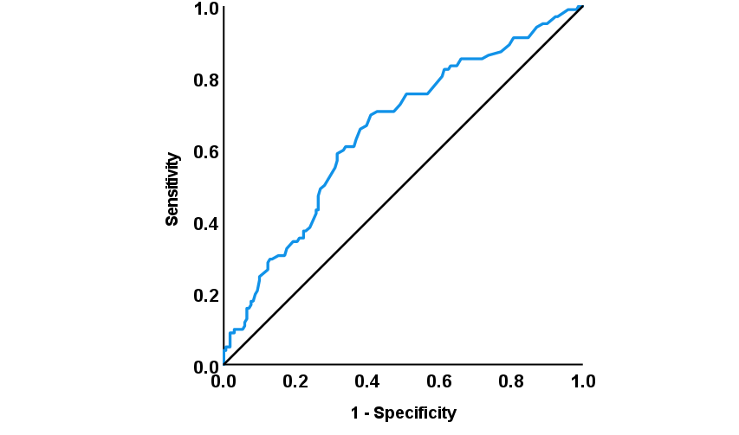 | 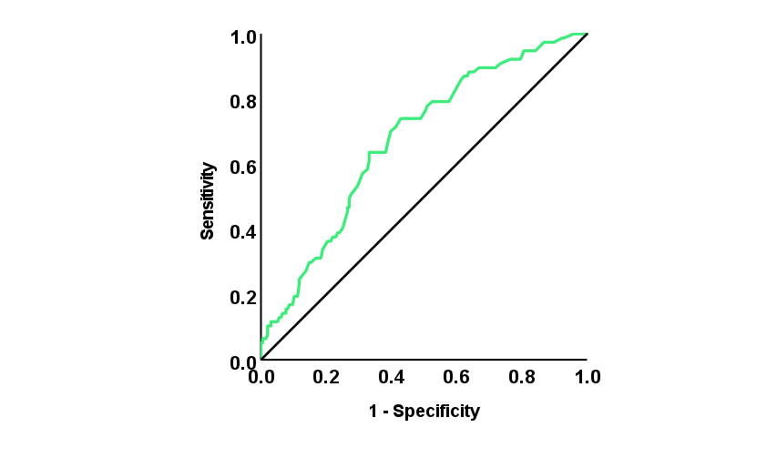
AUC = 0.65 (95% CI: 0.59-0.72) | AUC = 0.67 (95% CI: 0.61-0.74)
- BMI
≥ F2 (≥ 8.2 kPa) | ≥ F3 (≥ 9.7 kPa)
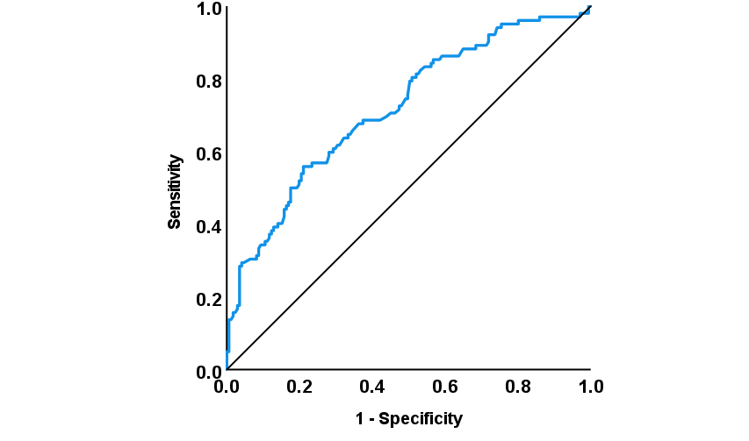 | 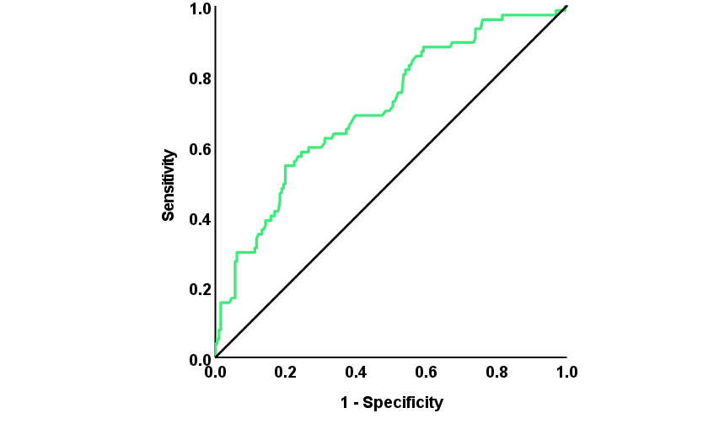
AUC = 0.72 (95% CI: 0.66-0.78) | AUC = 0.71 (95% CI: 0.64-0.78)
- HbA1c
≥ F2 (≥ 8.2 kPa) | ≥ F3 (≥ 9.7 kPa)
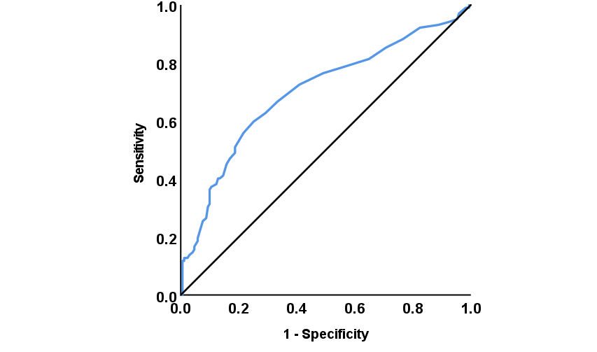 | 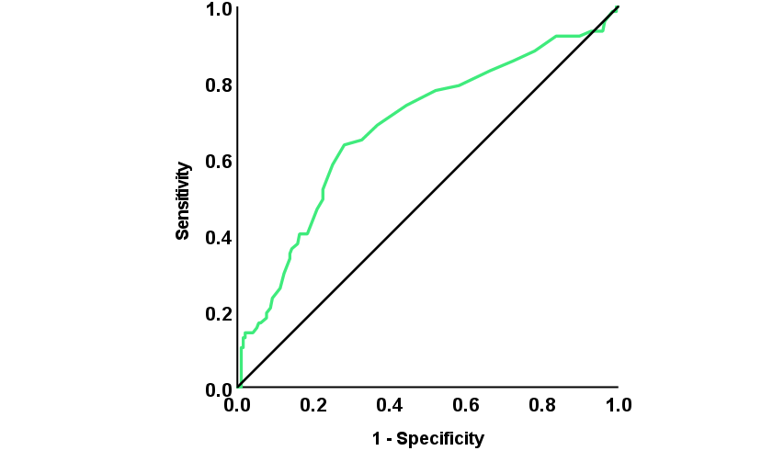
AUC = 0.70 (95% CI: 0.63-0.77) | AUC = 0.68 (95% CI: 0.61-0.76)
F2, moderate fibrosis; F3, severe fibrosis; ALT, alanine transaminase; BMI, body mass index; HbA1c, glycated hemoglobin; CI.

