Supplementary File 3. Development of algorithm.
Software used: SPSS statistics (version 27); Microsoft Excel and Microsoft Solver Excel plug-in.
Method
- 2020 data set (n = 273) screened for outliers. Excluded data:
- ALT >221 UL/L (n = 3)
- HbA1c >140 mmol/mol (n = 1)
- Total for algorithm training data n = 269
- A ‘fitting the risk model’ was adopted for this algorithm.
- Binary logistic regression analysis was used to find the predicted probability and group membership of the three predictor variables: ALT, BMI, and HbA1c. The dependent variable used was ≥ F2 (≥ 8.2 kPa).
- The regression analysis output was plotted on a graph (Fig. 1).  - The aim was to develop an equation that replicated the regression analysis on the graph, using ALT, BMI, and HbA1c.  - We arrived at the following equation:  ((patient ALT score – ALT y-intercept)*ALT multiplier^{Φ})+ ((patient BMI score – BMI y-intercept)* BMI multiplier^{Φ})+ ((patient HbA1c score – HbA1c y-intercept)*HbA1c multiplier^{Φ})  ^{Φ}multiplier comes from Excel Solver analysis of the training data set.  - The y-intercept of the best fit lines from the training data: ALT, BMI, and HbA1c was calculated (Fig. 2).  - Excel Solver computed the multiplier for each of the three variables.  - The missing values were added to the algorithm: ((patient ALT score – 28.826)*0.002638)+ ((patient BMI score – 23.291)* 0.02152)+((patient HbA1c score – 28.462)*0.009975).  - The algorithm was applied to the complete training data set (n = 269).  - The results of the algorithm were plotted on the graph (Fig. 1) for comparison with the logistic regression output. | Fig. 1. Comparison of the predicted probability of group membership for ≥ F2 using the calculated regression analysis and the ALBA algorithm  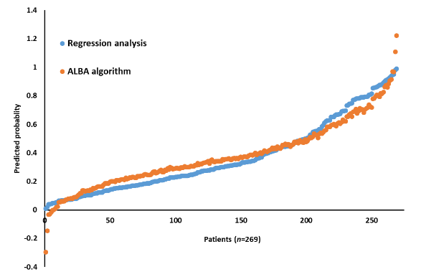  Fig. 2. y-intercept of the best fits lines for ALT, BMI, and HbA1c
ALT, alanine transaminase; HbA1c, glycated hemoglobin; BMI, body mass index; F2, moderate fibrosis; kPa, kilopascals.

References
Guidance from the following literature was used to help with constructing our algorithm:
Davies MJ, Gray LJ, Ahrabian D, et al. A community-based primary prevention program for type 2 diabetes mellitus integrating identification and lifestyle intervention for prevention: a cluster randomized controlled trial. Southampton (UK): NIHR Journals Library; 2017 Jan. Program Grants for Applied Research, No. 5.2. Chapter 3, Developing the risk score. Available from: https://www.ncbi.nlm.nih.gov/books/NBK409312/
Kebede Deribe, Lyndsey Florence, Abebe Kelemework, Tigist Getaneh, Girmay Tsegay, Jorge Cano, Emanuele Giorgi, Melanie J Newport, Gail Davey, Developing and validating a clinical algorithm for the diagnosis of podoconiosis, Transactions of The Royal Society of Tropical Medicine and Hygiene, Volume 114, Issue 12, December 2020, Pages 916–925, https://doi.org/10.1093/trstmh/traa074
Chava L Ramspek, Kitty J Jager, Friedo W Dekker, Carmine Zoccali, Merel van Diepen, External validation of prognostic models: what, why, how, when and where?, Clinical Kidney Journal, Volume 14, Issue 1, January 2021, Pages 49–58, https://doi.org/10.1093/ckj/sfaa188

