Supplementary File 1. Primary care liver pathway (abridged).
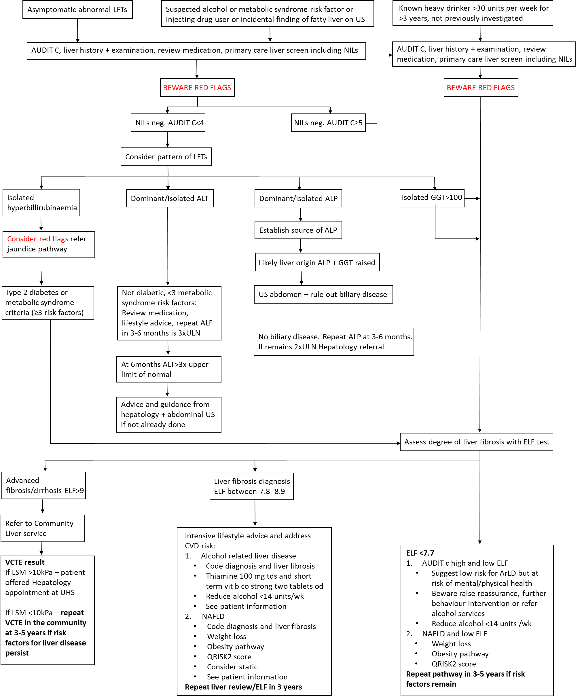
Full details of the Southampton primary care liver pathway can be found at: https://www.mysurgerywebsite.co.uk/website/J82081/files/LiverGuidance(Primary%20Care)STN1754.pdf

